CSI 2132 Project D1 Report
Student 1: Tong Zhao (300037013)
Student 2: Daniel Xu (300030558)

E-R Diagram:
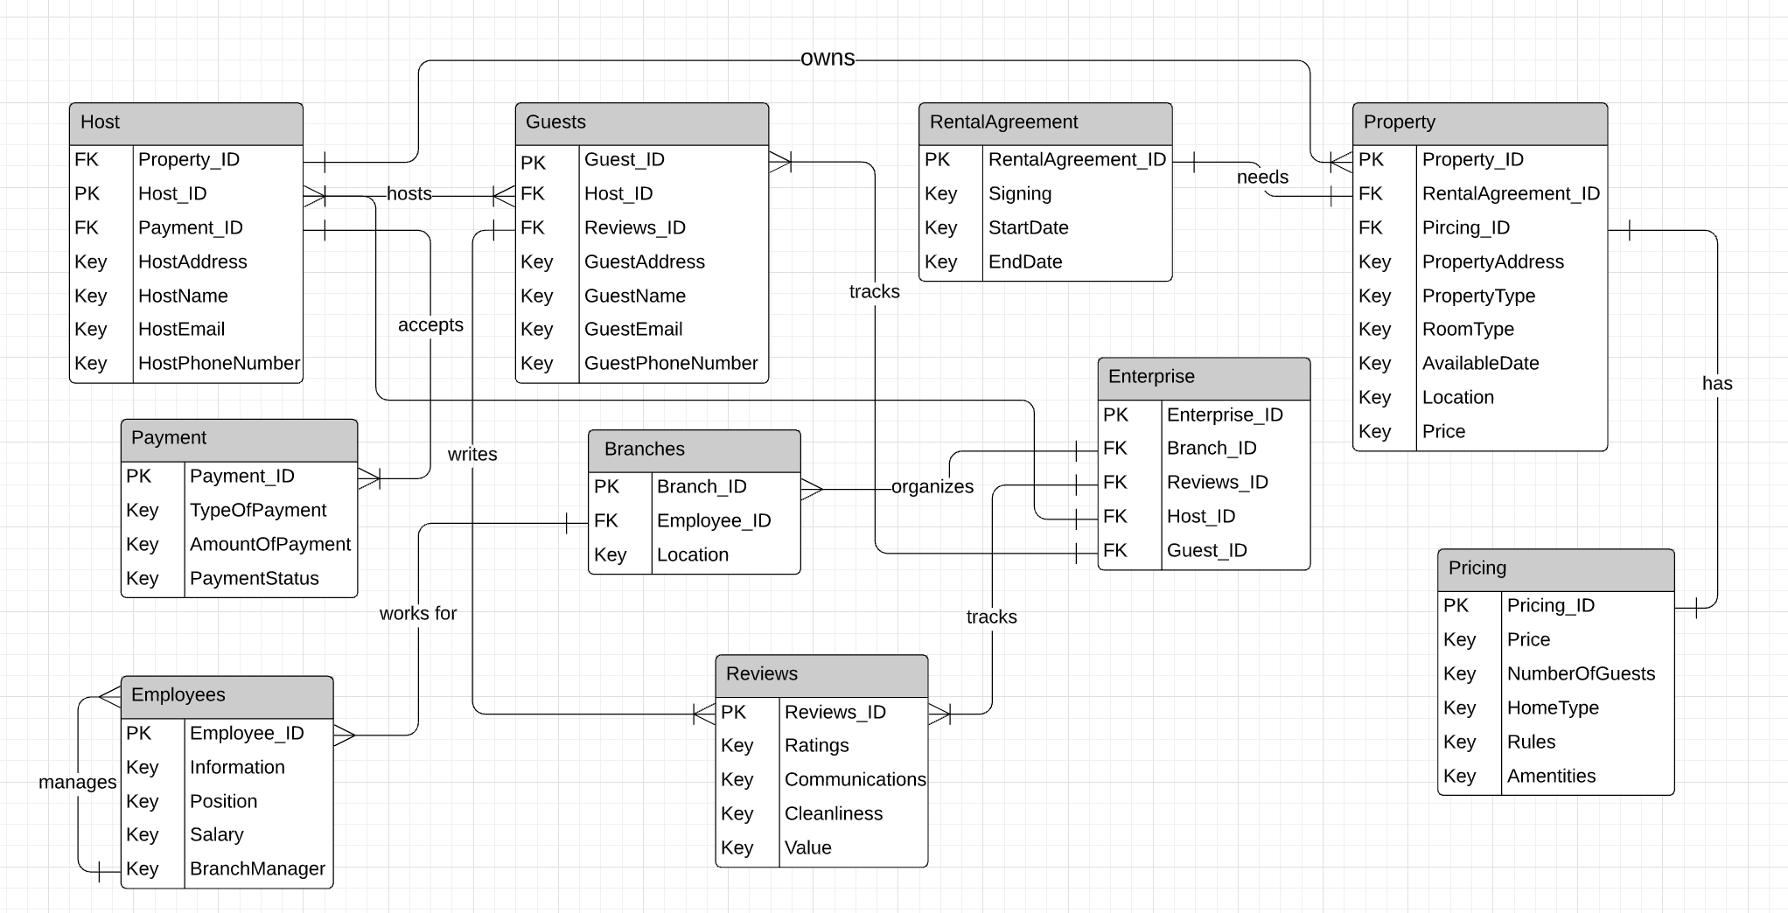

Relational Schema:
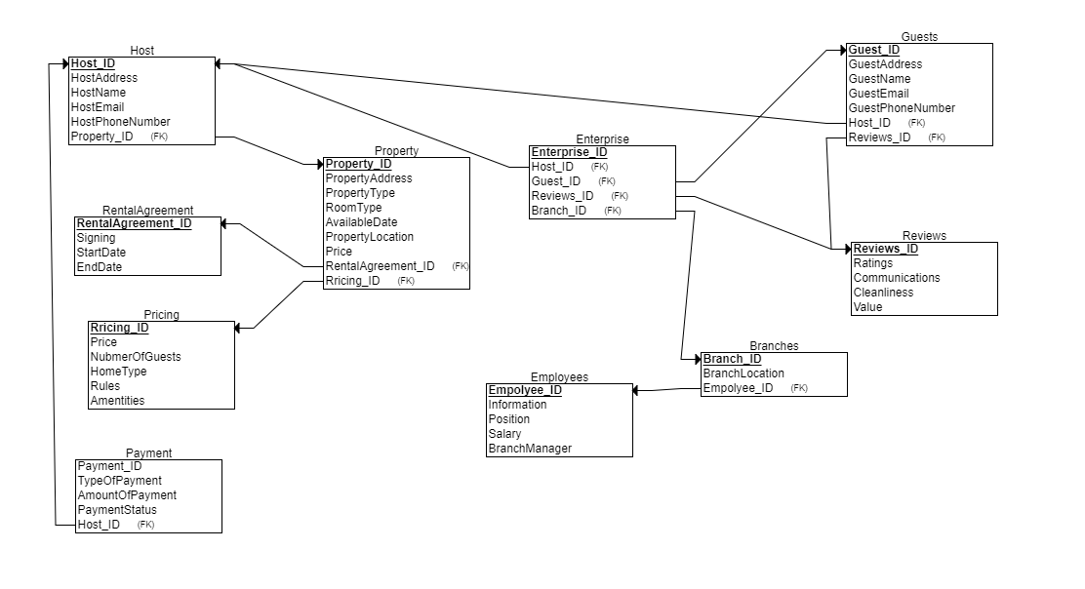

Constraints:

CREATE TABLE Host (
Host_ID INTEGER NOT NULL,
HostAddress VARCHAR(20),
HostName VARCHAR(20),
HostEmail VARCHAR(20),
HostPhoneNumber INTEGER(10),
FOREIGN KEY(Property_ID),
FOREIGN KEY(Payment_ID),
PRIMARY KEY(Host_ID)
);

CREATE TABLE Guests (
Guest_ID INTEGER NOT NULL,
GuestAddress VARCHAR(20),
GuestName VARCHAR(20),
GuestEmail VARCHAR(20),
GuestPhoneNumber INTEGER(10),
FOREIGN KEY(Host_ID),
FOREIGN KEY(Reviews_ID),
PRIMARY KEY(Guest_ID)
);

CREATE TABLE RentalAgreement (
RentalAgreement_ID INTEGER NOT NULL,
Signing VARCHAR(20),
StartDate DATE,
EndDate DATE,
PRIMARY KEY(RentalAgreement)
);

CREATE TABLE Property (
Property_ID INTEGER NOT NULL,
PropertyAddress VARCHAR(20),
PropertyType VARCHAR(20),
RoomType VARCHAR(20),
AvailableDate DATE,
Location VARCHAR(20),
Price INTEGER(10),
FOREIGN KEY(RentalAgreement_ID),
FOREIGN KEY(Pricing_ID),
PRIMARY KEY(Property_ID)
);

CREATE TABLE Payment (
Payment_ID INTEGER NOT NULL,
TypeOfPayment VARCHAR(10),
AmountOfPayment INTEGER(10),
PaymentStatus VARCHAR(10),
PRIMARY KEY(Payment_ID)
);

CREATE TABLE Branches (
Branch_ID INTEGER NOT NULL,
Location VARCHAR(20),
FOREIGN KEY(Employee_ID),
PRIMARY KEY(Branch_ID)
);

CREATE TABLE Enterprise (
Enterprise_ID INTEGER NOT NULL,
FOREIGN KEY(Branch_ID),
FOREIGN KEY(Reviews_ID),
FOREIGN KEY(Host_ID),
FOREIGN KEY(Guest_ID),
PRIMARY KEY(Enterprise_ID)
);

CREATE TABLE Employees (
Employee_ID INTEGER NOT NULL,
Information VARCHAR(20),
Position VARCHAR(20),
Salary INTEGER(10),
BranchManager VARCHAR(20),
PRIMARY KEY(Employee_ID)
);

CREATE TABLE Reviews (
Reviews_ID INTEGER NOT NULL,
Ratings INTEGER(1),
Communications VARCHAR(20),
Cleanliness VARCHAR(20),
Value VARCHAR(20),
PRIMARY KEY(Reviews_ID)
);

CREATE TABLE Pricing (
Pricing_ID INTEGER NOT NULL,
Price INTEGER(10),
NumberOfGuests INTEGER(1),
HomeType VARCHAR(20),
Rules VARCHAR(20),
Amenities VARCHAR(20),
PRIMARY KEY(Pricing_ID)
);

